Giuseppe Arcimboldo
Italian painter

Description
Giuseppe Arcimboldo was an Italian painter best known for creating imaginative portrait heads made entirely of objects such as fruits, vegetables, flowers, fish and books.
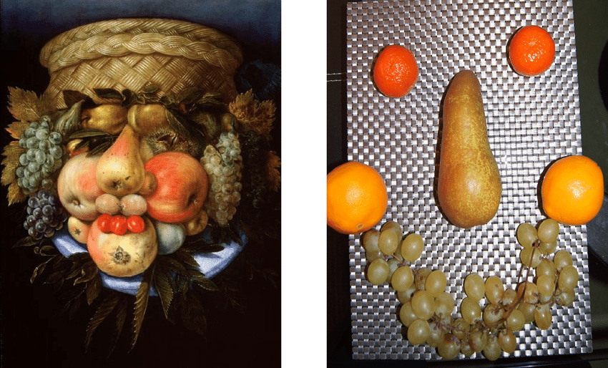

THIS WILL BE GREAT FUN AND I’D LOVE SOME PICS SENT TO ME!
YOUR MISSION IS TO “BORROW” SOME FRUIT, VEGETABLES, STICKS, LEAVES, FLOWERS AND CREATE A FACE LIKE THE ONE ABOVE! MAKE IT AS CRAZY, FREAKY AS YOU LIKE! DO DIFFERENT ONES, DO ONE OF YOUR TEACHER BUT MAKE ME LOVELY AND PRETTY!!

