First and Second Class - Virtual School Tour 2020
Ok boys and girls, we are off to Australia.
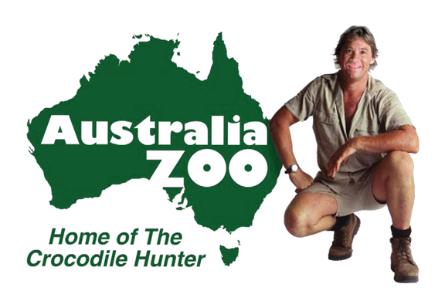
We are going to look at some videos created by the son of the crocodile hunter legend, Steve Irwin. Steve Irwin took over a small reptile park in 1991 and it has been transformed into this great zoo today.

- Watch the videos where Robert Irwin is going on a tour of the zoo. Take note of the native Australian animals because you will be doing a short report project on your favourite. (videos attached)
- Choose your favourite Australian animal – kangaroo, wombat, echidna, koala, crocodile, platypus, emu, dingo, Tasmanian devil, kookaburra (to name a few) Research some facts and write some sentences about your animal either in your copy or in a word document or powerpoint.
- Listen to the songs Waltzing Matilda and Kookaburra. Try to learn these songs and sing along to them. (videos attached)
- Listen to stories – Wombat Stew, Somewhere in Australia, Edward the Emu (videos attached)
- Do some aboriginal art (videos attached)

