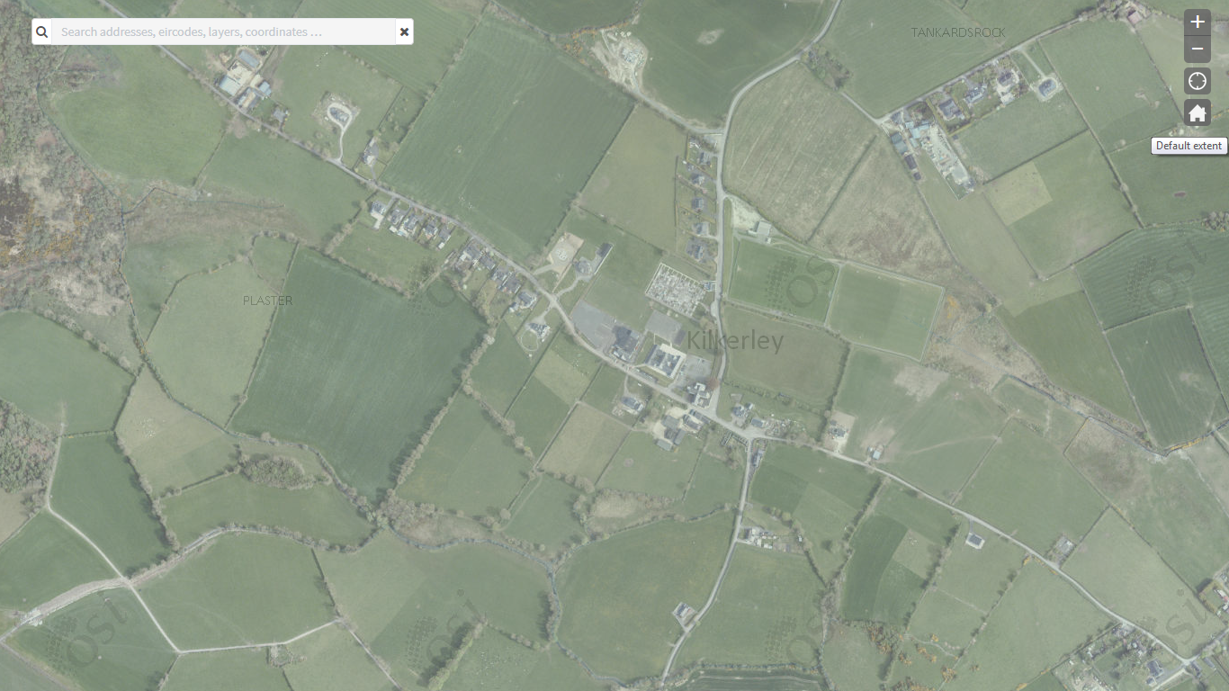
Kilkerley Aerial Map (Premium) 2005 – 2012 (Geohive – Ordnance Survey Ireland)

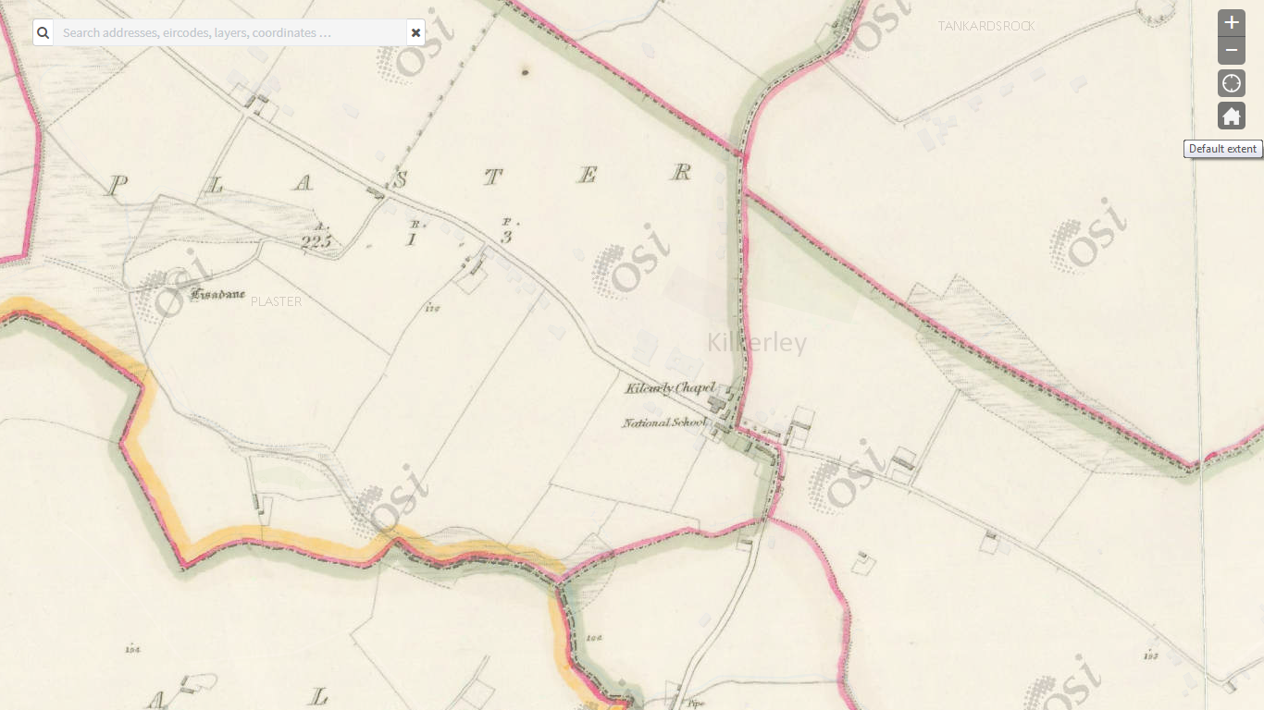
Kilkerley Historic Map 6-inch Colour 1837 – 1842 (GeoHive – Ordnance Survey Ireland)

