5th Class Weekly English Lesson (18th May – 22nd May) Miss Mulholland

1. Reading:
- Up and Running – Mr. Nobody (Poem) Pg. 201
- Way With Words – The Volunteer Pg. 78

2. Comprehension Activity:
- Way With Words
Pg. 79 – B
Make sure to use full sentences in your answers, not forgetting your capital letters and full stops.

3. Cloze Procedure:
- Complete the cloze procedure (below) by filling in the blanks. This cloze procedure is an informational report about owls. If you can, print out the page below, stick it into your SESE copy and simply fill in the missing words. Or you can rewrite the report into your Genre Writing copy or SESE copy.

4. Creative Writing (Poetry Writing)
You can use your Genre Writing or SESE copy for this activity.
- After reading the poem “Mr. Nobody”, (Up and Running, Pg. 201) have a discussion with somebody at home. Who do you think Mr. Nobody is? Why does he have that name? Have you ever done something wrong and blamed it on somebody else?
What words rhyme in this poem? Did the poet follow a pattern in the poem? Have many lines are in every stanza (verse)?
- Using the same rhyming pattern as Walter de la Mare, can you create your own poem about your home, the mess you might make and how you clean it up? Are you helping around the house as you “Stay Safe at Home”?
Tip: Before beginning to write your poem, brainstorm using a spider diagram. Gather words of action words you do in your home (e.g. sweep, wipe), things and places in your home. Can you spot any rhyming words?
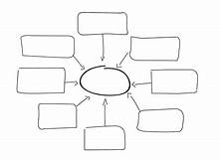

Fill in the blanks below with words from this box:
nocturnal  falcons  mice  stealthy  late  swallow  night | prey  eyesight  insects  hunt  flap  regurgitate  fish |  | hawks  hearing  birds  camouflage  feathers  pellets
Nocturnal Animals

Most owls are __________________ animals, which means they are mostly active at ___________________. Because they are active in the dark, they need keen ___________________ and ___________________.

Birds of Prey
Owls are birds of ___________________ like ___________________ and ___________________. That means they __________________ small animals such as ___________________, ___________________, and other ___________________. Some owls even catch ___________________ in water. Often, an owl will ___________________ an animal whole. But since it can’t digest the bones, it will ___________________ them. These regurgitated bits of food are called ___________________.

Owl Feathers
Owls are ___________________ hunters. They have special
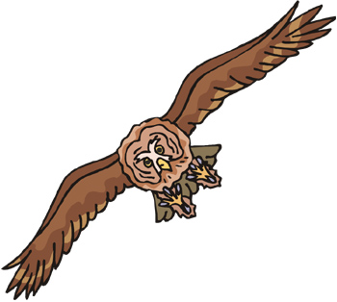 |  | ___________________ that help to keep them quiet when they ___________________ their wings. Owl feathers are usually brown and grey, which helps to ___________________ them in the forest. Because owls are so silent and hidden, their prey doesn’t know the owls are coming until it’s too ___________________.

