5th Class Weekly Gaeilge Lesson 5th May – 8th May
Miss Mulholland
Topic: An Aimsir (An Rinc Scátála Oighir)

Your first step is to create a Folens Online account for yourself – this will make sure you can access all the activities, stories, and games that we usually use in school.

Log on to FolensOnline.ie and click register
Select “Teacher”
Fill in a username, email and password
For Roll number, use the code: Prim20

Once you have created an account – you should be able to spot “Abair Liom”, click on the “Resources” button.

This is where you will find any online resources that I mention in the work I have organised for you. Since our topic this week is “An Aimsir”, if you click the “Theme” button, and look for “An Aimsir”, that is where you will find everything for this week’s work.

If you have any problems creating an account or finding the resources, please email me to let me know and I will do my best to help you.

Here is work for you to complete this week:

1. Ag Éisteacht
- Listen to “Póstaer – 15. An Rinc Scátála Oighir” and follow along on Pg. 108 of your Abair Liom.

2. Fóclóir agus Frásaí
I have attached the new Foclóir and Frásaí for An Aimsir to this blog and I have included a recording of the Foclóir and Frasaí for this week so that you can get a hang of how to pronounce the words. Try to read the fóclóir and frásaí along with my voice, and learn these phrases as best you can.
Activity to practise fóclóir agus frásaí:
- Target Practise:
Scríobh na focail agus frásaí ar páipeár agus cur ar balla é. Abair an focail agus déan iarracht an focal a bhuail leis an liathróid!

3. Ag Scríobh:
- Léigh “Spraoi ag Scátáil”. Freagair na ceisteanna ar lth. 109.

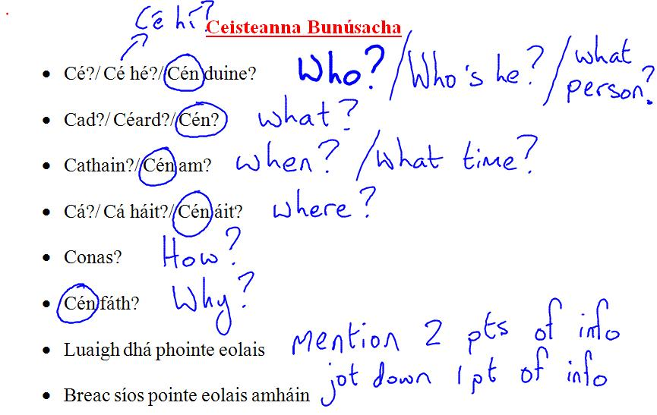

- https://seideansi.ie/rang-a-tri-se.php
A fabulous website which can be used to explore all areas of Irish grammar.

