5th Class Weekly Gaeilge Lesson 18th May – 22nd May
Miss Mulholland
Topic: An Aimsir (Tom Crean)

Your first step is to create a Folens Online account for yourself – this will make sure you can access all the activities, stories, and games that we usually use in school.

Log on to FolensOnline.ie and click register
Select “Teacher”
Fill in a username, email and password
For Roll number, use the code: Prim20

Once you have created an account – you should be able to spot “Abair Liom”, click on the “Resources” button.

This is where you will find any online resources that I mention in the work I have organised for you. Since our topic this week is “An Aimsir”, if you click the “Theme” button, and look for “An Aimsir”, that is where you will find everything for this week’s work.

If you have any problems creating an account or finding the resources, please email me to let me know and I will do my best to help you.

Here is work for you to complete this week:

1. Ag Léamh
- Ar lth. 114, léamh “Tom Crean”. Is feidir leat éisteacht leis an scéal ar “FolensOnline.ie”, bain úsáid as na treoracha thuasluaite.

- Ar lth. 115, freagair na ceisteanna A. 1 – 9.
Don’t forget your question words, and use a dictionary if you need to.

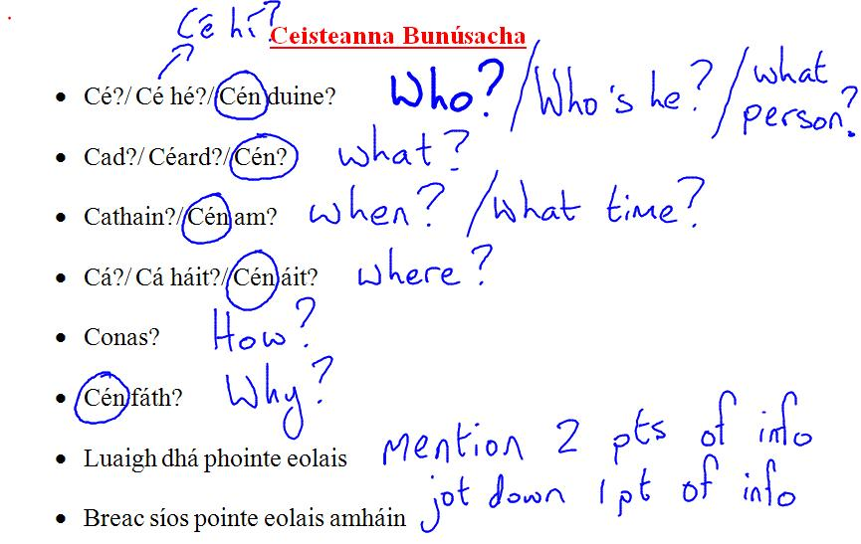

2. Fóclóir agus Frásaí
I have attached the new Foclóir and Frásaí for An Aimsir to this blog and I have included a recording of the Foclóir and Frasaí for this week so that you can get a hang of how to pronounce the words. Try to read the fóclóir and frásaí along with my voice, and learn these phrases as best you can.
Activities to practise your vocabulary...
- Bain triail as an Crosfhocal (attached to the bottom of this file)
- Bain triail as crosfhocal a dhéanamh! (click on the website below for a crossword maker)
Use the ”focail” as the answers, and use the “frásaí” to help make clues!
https://worksheets.theteacherscorner.net/make-your-own/crossword/

3. Ag Scríobh
- Ar lth. 116, bain triail as abairtí a dhéanamh “E – Cén séasúr is fearr leat?”, ag baint úsaid as na frásaí agus pictiúir ar an leaethanach sin.
Tip: Use the first sentence as an example, to help you structure the other 3 sentences. Abair liom take out words as you go, to let you write them in yourself. Also, remember that these books are on loan from the school, so rewrite the sentences into your copy.

4. Ag Éisteacht
- Éist le “Trasna na dTonnta”. Bainigí triail as é a chanadh!

Crosfhocal

