5th Class Weekly Maths Lesson (15th June – 19th June)
Miss Mulholland
Topic: Equations and Chance

Your first step is to log on to cjfallon.ie (this website creates your Busy at Maths book) and click on Parent / Student resources at the bottom right corner of the webpage.
Then click Student Resources

This will bring you to a page that shows all of CjFallon’s resources – we only need our 5th class Busy at Maths resources from this page at the moment.
Start with the box on the left and click Primary , move to the next box and click 5th Class, move to the next box and click Maths, move to the next box and click Busy at Maths, move to the next box and click Busy at Maths 5 – Fifth Class, and last of all click Interactive.
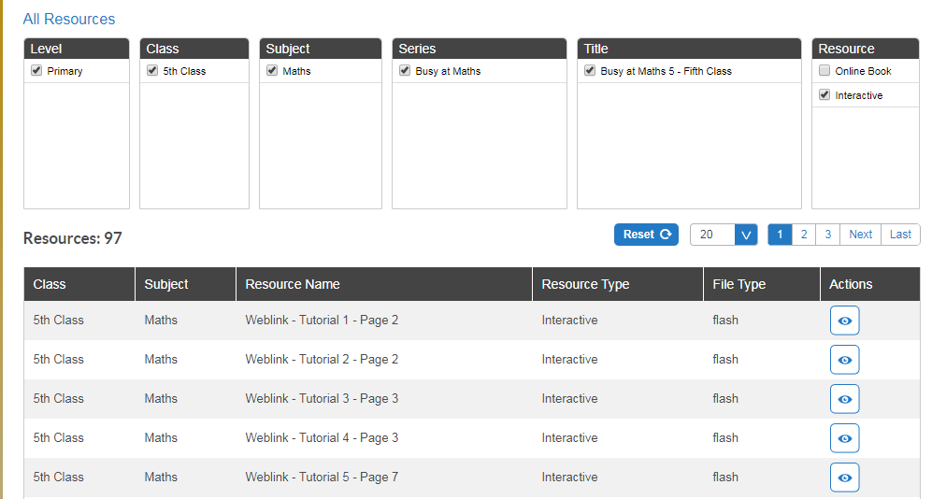

(Of course, you are free to explore all those resources for all the subjects we cover! I am just showing you how to find the resources you need for the lessons below)

1. Equations
- Read the explanations of closed and open sentences in your Busy at Maths on pg. 156.

- Watch the YouTube video attached below. Where this man draws an “x”, imagine that “x” is the empty box or a “frame” as it is called in your Busy at Maths on pg. 156.

- On the CjFallon app (above) find and play Weblink Tutorial 90 – Pg. 156

- On pg. 156 of your Busy at Maths, try (a), (b), (c) and (d) from Q1, Q2, Q3 and Q4. So only 16 equations altogether.

- On the CjFallon app (above) find and play Weblink Tutorial 91 – Pg. 157

- On pg. 157 of your Busy at Maths, try (a), (b), (c) and (d) from Q1 and Q2. So only 8 equations altogether.

2. Problems as Equations
- Watch LiveBoard video “Problems as Equations”, attached to the blog post.

- On pg. 158 of your Busy at Maths, try (a), (b) and (c) from Q1, Q2 and Q3.

- Play the game below to practise your fractions, decimals and percentages.
https://www.helpingwithmath.com/resources/games/fraction_game5/frac_percent_dec01.html

- On pg. 159 of your Busy at Maths, try (a), (d) and (g) from Q1, Q2 and Q3.

3. Chance
- On the CjFallon app (above) play the Weblink Tutorial 97 – Pg. 177

- On pg. 177 of your Busy at Maths, try Q1 – Q6.

- Watch the YouTube video below on determining chance.
https://www.youtube.com/watch?time_continue=14&v=GMiAbQ5yUDA&feature=emb_logo

- On pg. 178, try Q2 and Q3.

- On pg. 179, read the yellow box at the top of the page, and try Q1 and Q2 with somebody at home!

4. Chance - Fractions and Percentages
- Watch LiveBoard video “Chance – Fractions and Percentages”, attached to blog.

- On pg. 180, try Q3.

- On pg. 181, try Q2.

