**5th Class Weekly Maths Lesson (18th May – 22nd May)**

**Miss Mulholland**

**Topic: Weight**

Your first step is to log on to cjfallon.ie (this website creates your Busy at Maths book) and click on Parent / Student resources at the bottom right corner of the webpage.

Then click Student Resources

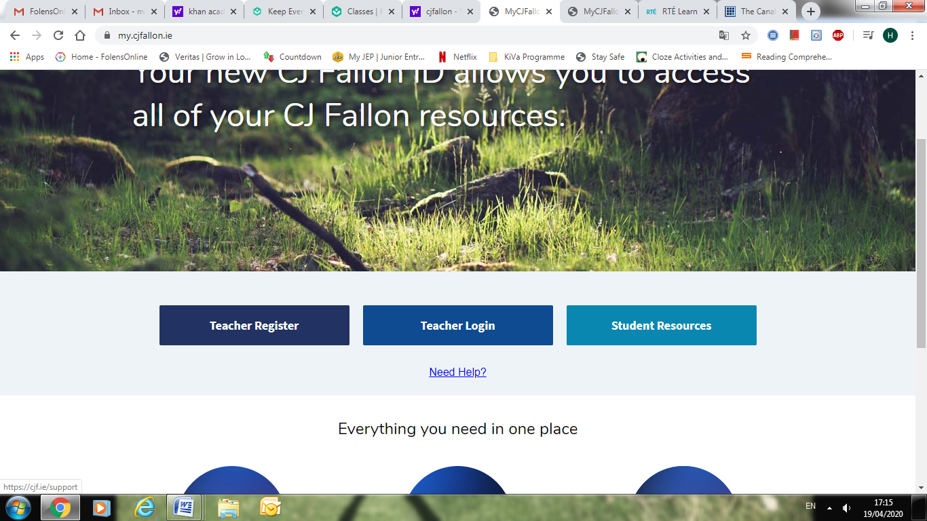

This will bring you to a page that shows all of CjFallon’s resources – we only need our 5th class Busy at Maths resources from this page at the moment.

Start with the box on the left and click Primary , move to the next box and click 5th Class, move to the next box and click Maths, move to the next box and click Busy at Maths, move to the next box and click Busy at Maths 5 – Fifth Class, and last of all click Interactive.

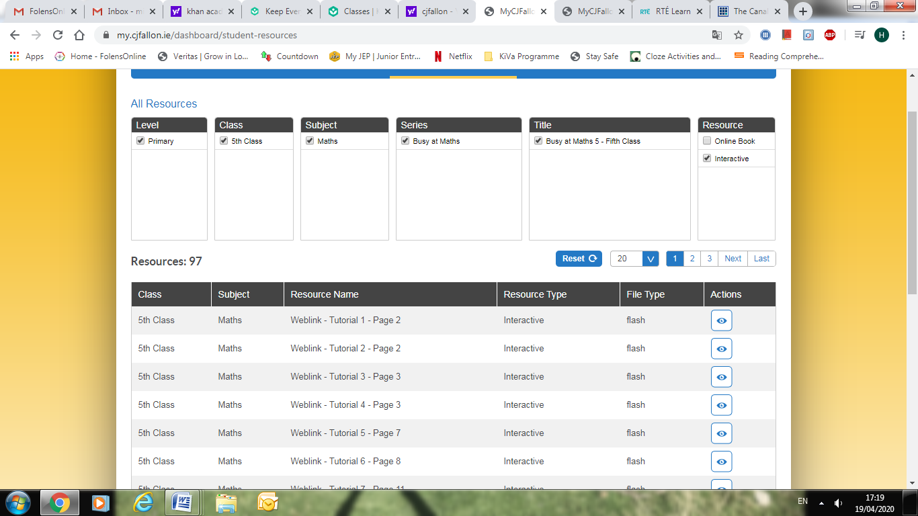

(Of course, you are free to explore all those resources for all the subjects we cover! I am just showing you how to find the resources you need for the lessons below)

1. Approximate Weight

* On pg. 135, read about the common weights of everyday objects in the yellow box.
* Weight Scavenger Hunt Challenge:

In your house, can you find objects that you think weigh...

- 1kg

- 500g

-250g

- 5g

- 1g

Once you have found the 5 objects, can you weigh the items and see if you were correct with your estimate?

If you do not have a weighing tool to measure the weight of the items, can you order the items from heaviest to lightest?

* Then try questions (a) – (j) on the same page. You are estimating the weight of the objects, and deciding what you would use to weight each one. For example, we wouldn’t use a kitchen scale to weigh an elephant! ☺

2. Kilogrammes using fractions and decimals

* <https://www.ictgames.com/mobilePage/mostlyPostie/index.html>

A simple, fun game to practise reading scales. Since you’re in 5th class, make it a little bit trickier and write the answer in grams only. (Click the yellow button that says kg / g)

* On pg. 136, try (b), (c) and (d) of Q1, Q2, Q3 and Q4. So you are only completing 3 problems of every question, only 12 altogether. I hope that makes sense!

Here you are changing kilogrammes into fractions and decimals – remember how many places after the decimal point we put 1/1000 – 3 places after the decimal point. The examples in the yellow boxes are a big help on this page.

3. Weight: +, -, x and ÷

* Watch the Liveboard video – “Weight: +, -, x and ÷ ” (attached to blog post)
* On pg. 137 of your Busy at Maths, try (b) and (c) of Q1, Q2, Q3, Q4 and Q5. This way you will revise all! ☺

4. Real-life problems

* Go to www.khanacademy.org

Click on login (You can find your login and password at the bottom of this document)

Once you have successfully logged in, you should see “Miss Mulholland’s 5th Class” followed by 3 assignments...

“Understanding Mass” is a very helpful video to watch, which explains mass and weight.

“Estimate Mass” and “Convert to smaller units (g and kg)” are two activities to follow.

* Using the equations from the previous page (pg. 137), you must now read the real-life problems and decide what equation to use. You might have to add, subtract, multiply or divide depending on the question you are being asked.

Try Q 2, 3 and 4 on pg. 138.

5. Food, glorious food!

* On the CjFallon app (above) find and watch Weblink 82.
* Try Q1 on pg. 139. You might have to multiply or divide the price of the product to find how much on kg will cost.

**Khan Academy Logins**

