5th Class Weekly Maths Lesson (25th May – 29th May)
Miss Mulholland
Topic: Number Theory

Your first step is to log on to cjfallon.ie (this website creates your Busy at Maths book) and click on Parent / Student resources at the bottom right corner of the webpage.
Then click Student Resources

This will bring you to a page that shows all of CjFallon’s resources – we only need our 5th class Busy at Maths resources from this page at the moment.
Start with the box on the left and click Primary , move to the next box and click 5th Class, move to the next box and click Maths, move to the next box and click Busy at Maths, move to the next box and click Busy at Maths 5 – Fifth Class, and last of all click Interactive.
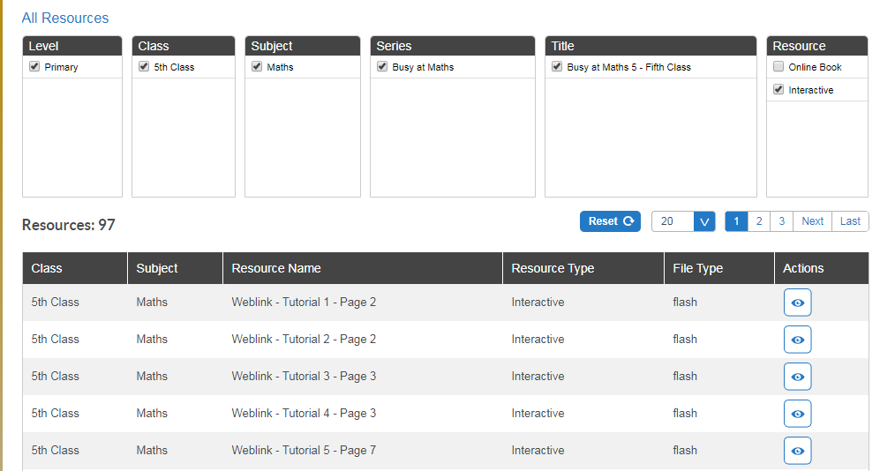

(Of course, you are free to explore all those resources for all the subjects we cover! I am just showing you how to find the resources you need for the lessons below)

1. Factors and Products
- Log in to www.khanacademy.org and you should see “Miss Mulholland’s 5th Class” followed by 2 assignments.
Watch “Factors and Multiples: Days of the Week” and complete the activity “Patterns with Numbers”.

- On pg. 141, try Q2. You have been asked to write the related pairs of factors for each of the numbers AND to order the factors starting from the smallest.
Here is an example of (b)
9 = (1, 9), (3, 3) | 1, 3, 9

2. Multiples
- Here is where the practise of your tables will really shine!!
Before you start, try the speed test on timestables.com, using the “All Tables” button to practise all!
https://www.timestables.com/speed-test/

- On the CjFallon app (above) find and play Weblink Tutorial 84

- On pg. 142, try 2. Time yourself and see how quick you can complete this activity (just like we did in class, where I would use a timer to see who could write out their tables as quick as they could on whiteboards).

3. Prime and Composite Numbers
- Have a look at the yellow boxes on pg. 143, they explain the difference between a prime and a composite number, and they also show you some excellent tricks to determine if numbers are prime or composite. Take your time to read through them.

- Watch this video, which further explains Eratosthenes method:
https://www.youtube.com/watch?v=V08g_lkKj6Q

- On pg. 143 of your Busy at Maths, try Q1 and Q2 (I have attached a hundred square to the bottom of this document that you can print – it might save you photocopying or writing out a hundred square) and try Q3 on pg. 144.

4. Odd and Even Numbers
- Using this website - http://www.amathsdictionaryforkids.com/ , see can you find the definition for Prime numbers, Composite numbers, square numbers and lastly, rectangle numbers. Write down the definitions into your hardback copy. Draw a diagram if you would like to.

- Read about Goldbach, the mathematician on pg. 145. Try Q5, using your hundred square from the previous question to help you with the prime numbers.
- On pg. 146, try Q 1 and Q 2.

5. Square Numbers
- https://www.mathsisfun.com/square-root.html
Have a look at this website, which explains square numbers very well.

- On pg. 147, read the yellow boxes and try Q 4 at the bottom of the page.

