5th Class Weekly Maths Lesson (8th – 12th June)
Miss Mulholland
Topic: The Circle

Your first step is to log on to cjfallon.ie (this website creates your Busy at Maths book) and click on Parent / Student resources at the bottom right corner of the webpage.
Then click Student Resources

This will bring you to a page that shows all of CjFallon’s resources – we only need our 5th class Busy at Maths resources from this page at the moment.
Start with the box on the left and click Primary , move to the next box and click 5th Class, move to the next box and click Maths, move to the next box and click Busy at Maths, move to the next box and click Busy at Maths 5 – Fifth Class, and last of all click Interactive.
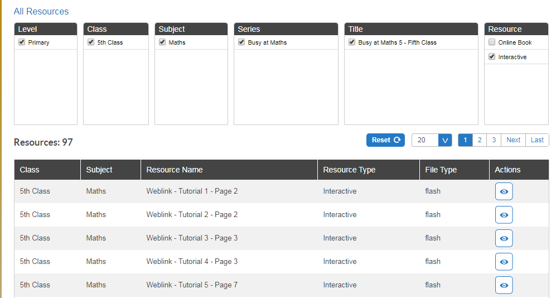

(Of course, you are free to explore all those resources for all the subjects we cover! I am just showing you how to find the resources you need for the lessons below)

1. Parts of the Circle
- Watch the Liveboard Video “Part of the Circle” attached to the blog post.

- On the CjFallon app (above) find and play Weblink Tutorial 85 – Pg. 148

- On pg. 148 of your Busy at Maths, try Q 1 and Q 2.

2. Drawing Circles (You will need a compass and ruler for this part of the lesson)
- Watch the Youtube video below which explains how to use a compass
https://www.youtube.com/watch?time_continue=36&v=02XRad7s1Io&feature=emb_logo

- On the CjFallon app (above) watch the Weblink Tutorial 86 - Pg. 149

- On pg. 149 of your Busy at Maths, try Q 1 (problem solving using radii and diameters) and Q 2 (drawing circles with specific radii) and Q 3 (drawing circles with specific diameters – remember, a diameter of a circle is a straight line from one side of a circle to another, and it is double the length of the radius. So to find the radii of these circles you have to half the diameter, then you can go ahead and use your compass as usual)

3. Area of a Circle
- On the CjFallon app (above) watch the Weblink Tutorial 87 – Pg. 150.

- On pg. 150, try Q 1 and Q 3.

4. Chapter 28: Data 3 – Pie Charts
- Watch Liveboard Video “Pie Charts” attached to blog post

- On CjFallon app (above) watch the Weblink Tutorial 88 – Pg. 153

- On pg. 152, try Q 3, and on pg. 153, try Q 1 and Q 2

5. Constructing Pie Charts (You will need a protractor for this part of the lesson)
- Watch https://math.wonderhowto.com/how-to/use-protractor-make-pie-chart-333915/
The video quality is not great but I like how she has explained where to place your protractor, and how to rotate the protractor too.

- On CjFallon app (above) watch Weblink Tutorial 89 – Pg. 154

- On pg. 154, read the yellow box very carefully.

- On pg. 154, try Q 1 and Q 2 – draw your own pie chart to represent the data on favourite soups.

