5th Class Weekly Maths Lesson (20th – 24th April) Miss Mulholland
Topic: Area

Your first step is to log on to cjfallon.ie (this website creates your Busy at Maths book) and click on Parent / Student resources at the bottom right corner of the webpage.
Then click Student Resources

This will bring you to a page that shows all of CjFallon’s resources – we only need our 5th class Busy at Maths resources from this page at the moment.
Start with the box on the left and click Primary , move to the next box and click 5th Class, move to the next box and click Maths, move to the next box and click Busy at Maths, move to the next box and click Busy at Maths 5 – Fifth Class, and last of all click Interactive.
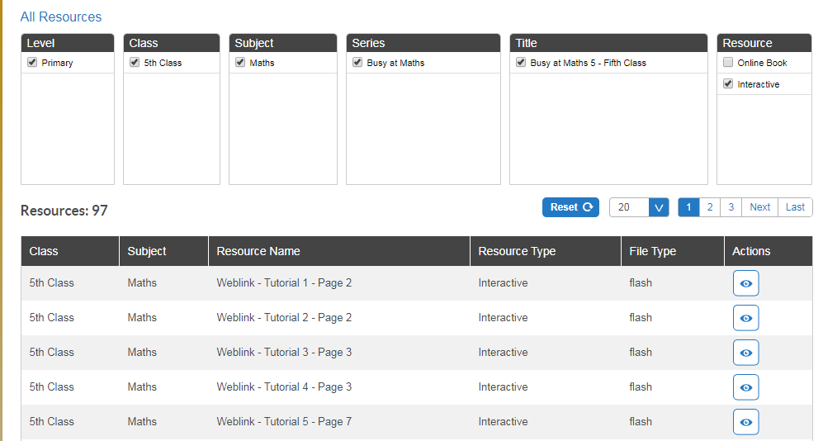

(Of course, you are free to explore all those resources for all the subjects we cover! I am just showing you how to find the resources you need for the lessons below)

1. Revision of Area of Regular Shapes
- On the CjFallon app (above) find and play Weblink Tutorial 68 and Weblink Tutorial 69. These tutorials and games are about measuring area using 1cm squared.
- Complete Pg. 114 Q 2 and Q 3 in your copy.

2. Area and Perimeter of Irregular Shapes
- Watch: https://www.youtube.com/watch?v=hqqtumES-rQ
Remember: We know how to find the area (length x width) of rectangles and squares – so maybe we have to separate an irregular shape into a few rectangles/squares. Have a look at Pg. 117 (Yellow box)
- Play Weblink Tutorial 70 on CjFallon website. (Find missing lengths)
- Complete Pg. 117 Q. 2
Busy at Maths have some missing measurements in questions b, d and e – I have added them in below so you can complete the questions. Thank you to a very keen eye in 5th class! :D
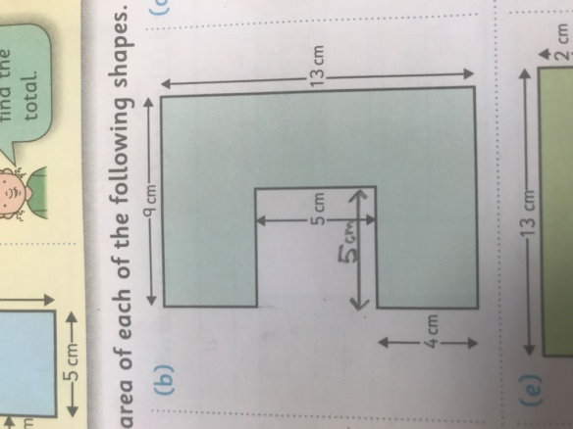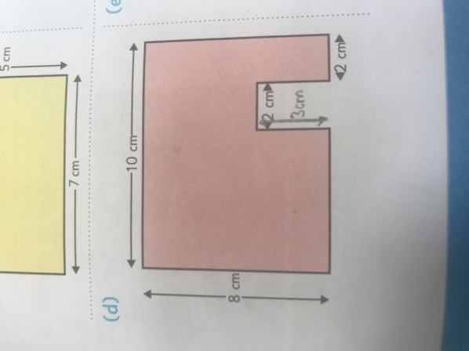

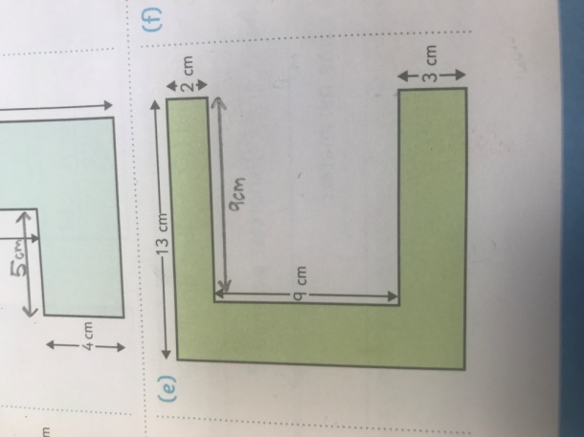

3. Outdoor Activity
- Using a ruler, can you measure out 100cm or 1metre of string? (This should be length of about 3 and a third 30cm rulers) Once you have cut the string – you now have your own metre stick!
- Can you find a regular shape in your garden? For example, a square patch of grass, a rectangular area of concrete? Try to measure the length and width of the area using your metre string. Can you calculate the area?

