**5th Class Weekly Maths Lesson (5th May – 8th May)**

**Miss Mulholland**

**Topic: Directed Numbers**

Your first step is to log on to cjfallon.ie (this website creates your Busy at Maths book) and click on Parent / Student resources at the bottom right corner of the webpage.

Then click Student Resources



This will bring you to a page that shows all of CjFallon’s resources – we only need our 5th class Busy at Maths resources from this page at the moment.

Start with the box on the left and click Primary , move to the next box and click 5th Class, move to the next box and click Maths, move to the next box and click Busy at Maths, move to the next box and click Busy at Maths 5 – Fifth Class, and last of all click Interactive.

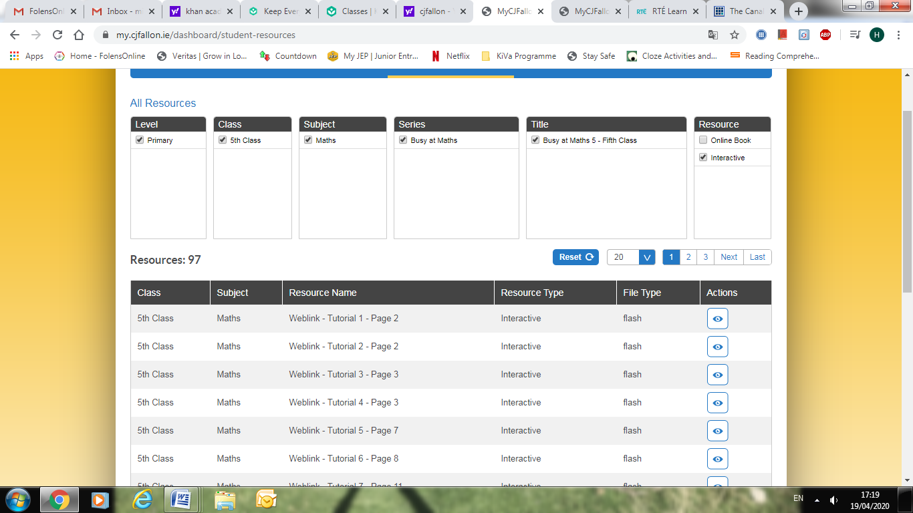

(Of course, you are free to explore all those resources for all the subjects we cover! I am just showing you how to find the resources you need for the lessons below)

1. Introduction to Directed Numbers

* Go to www.khanacademy.org

Click on login (You can find your login and password at the bottom of this document)

Once you have successfully logged in, you should see “Miss Mulholland’s 5th Class” followed by 2 new assignments:

Watch “Intro to Negative Numbers” video and complete the assignment “Intro to Negative Numbers” below.

If you did not manage to log into Khan Academy, you can simply click this link to watch the video:

<https://www.khanacademy.org/math/arithmetic/arith-review-negative-numbers/arith-review-neg-num-intro/v/negative-numbers-introduction>

* On the CjFallon app (above) find and play Weblink Tutorial 75
* Have a look at Busy at Maths Pg. 125

***Here, we are exploring positive and negative numbers.***

Try Q 1, Q 2 and Q 3

2. Temperature

* On the CjFallon app (above) find and play Weblink Tutorial 76
* Have a look at Busy at Maths Pg. 126 and read the blue and orange boxes.

Try Q 1

* Try worksheet “Basic Negative Numbers and Temperature” (attached to blog post)

Feel free to print off worksheet or simply complete in your copy.

3. League Tables

* View Screenomatic Video on League Tables (attached to blog post) whilst keeping an eye on pg. 128 of your Busy at Maths
* Have a look at Busy at Maths Pg. 128

Try Q 1 - 5

4. Look back at Percentages (Increasing and Decreasing)

* On the CjFallon app (above) watch Weblinks 73 and 74 (We have looked at these videos last week, but it is always a good idea to revise)

***Example 2 below shows the way we have practised finding the full amount.***

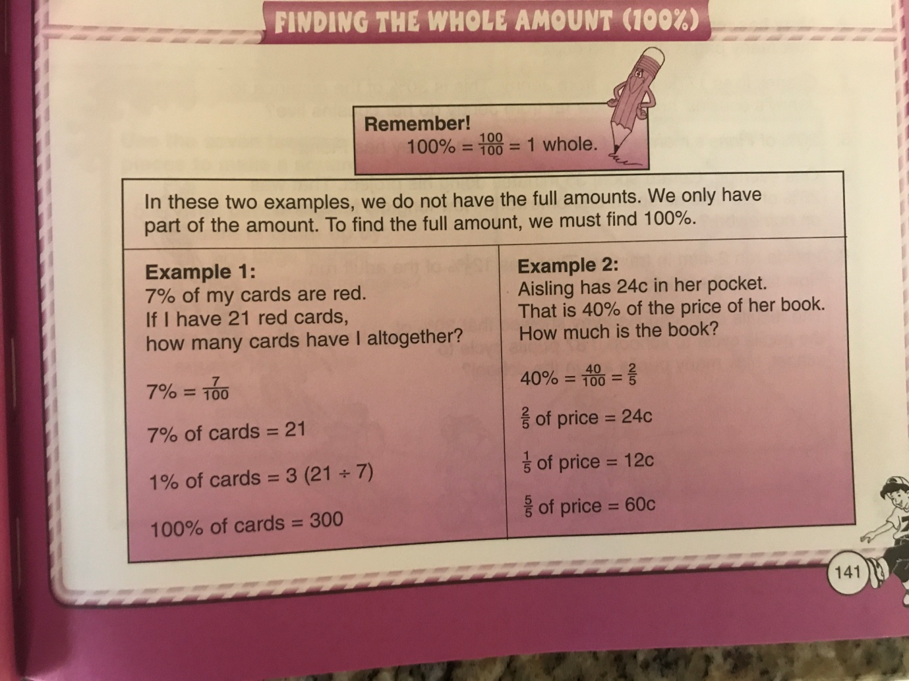

* Have a look at Busy at Maths Pg. 124

Try Q 3, Q 5, Q 8 and Q 9

Khan Academy Logins

Please respect your classmates and only use your own login details.

