5th Class Weekly Maths Lesson (11th May – 15th May)
Miss Mulholland
Topic: Fractions, Decimals ad Percentages

Your first step is to log on to cjfallon.ie (this website creates your Busy at Maths book) and click on Parent / Student resources at the bottom right corner of the webpage.
Then click Student Resources

This will bring you to a page that shows all of CjFallon’s resources – we only need our 5th class Busy at Maths resources from this page at the moment.
Start with the box on the left and click Primary , move to the next box and click 5th Class, move to the next box and click Maths, move to the next box and click Busy at Maths, move to the next box and click Busy at Maths 5 – Fifth Class, and last of all click Interactive.
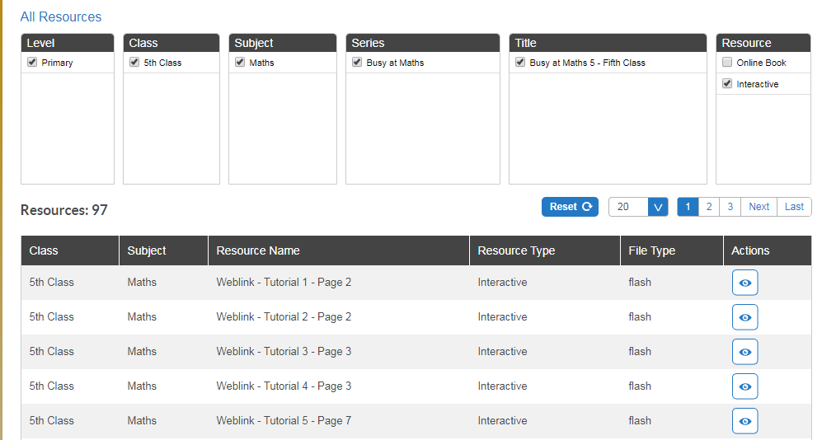

(Of course, you are free to explore all those resources for all the subjects we cover! I am just showing you how to find the resources you need for the lessons below)

1. Revision of Fractions, Decimals and Percentages
- A fun game to get your mind thinking “Fractions”!
https://www.mathplayground.com/number_bonds_fractions.html

- On the CjFallon app (above) find and watch Weblink Tutorial 77.
It clearly explains how to find the sale price of an item. We find the sale price in the same way we decrease a number by a percentage.

- To revise fractions, decimals and percentages, try Q1 on pg. 129.

- Then try Q2 on the same page.

2. Percentage Extra Free
- On the CjFallon app (above) find and watch Weblink Tutorial 78.
This tutorial explains how to calculate the new amount of a product, when we get a percentage for free.

- On pg. 130 of your Busy at Maths, try Q1.

- Watch the Liveboard video – “Percentage Extra Free” (attached to blog post)

- On pg. 130 of your Busy at Maths, try Q2.

3. Changing fractions to decimals and percentages
- Watch the Liveboard video – “Changing fractions to decimals and percentages” (attached to blog post)

- On the CjFallon app (above) find and play Weblink 79.

- On pg. 131 of your Busy at Maths, try Q1 and Q2 (You can use your calculator for Q2!)

4. Using your Calculator!
- On the CjFallon app (above) find and watch Weblink 80.

- Try Q2 on pg. 132 of your Busy at Maths
The first question (a) shows a boy with €20. He wants to buy a ticket for the cinema, which will cost him €7. What percentage of his money.... can you finish the word sentence?

5. Increasing and Decreasing
- On the CjFallon app (above) find and watch Weblink 81.

- On pg. 133, have a close look at the yellow boxes on that page – they explain how to increase or decrease by a percentage using a calculator.
Try Q 3 on pg. 133 of your Busy at Maths.
If you have no access to a calculator and you are using a phone instead, the calculator on the phone might work slightly different. When I try Q3 (a) on my phone, I have to press = to get the answer.

