**5th Class Weekly Maths Lesson (27th April – 1st May) Miss Mulholland**

**Topic: Percentages 2**

Your first step is to log on to cjfallon.ie (this website creates your Busy at Maths book) and click on Parent / Student resources at the bottom right corner of the webpage.

Then click Student Resources

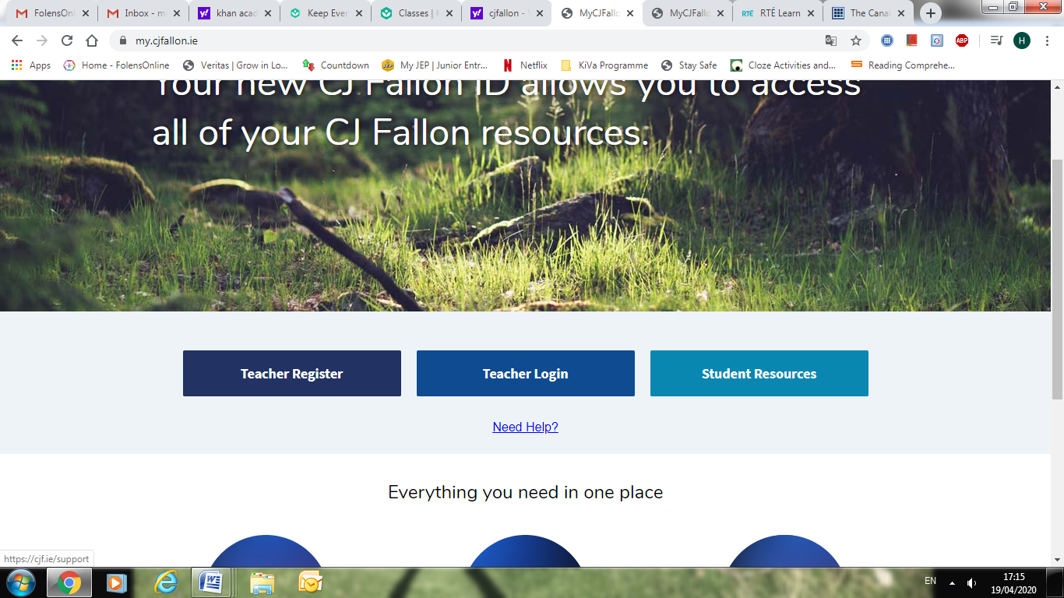

This will bring you to a page that shows all of CjFallon’s resources – we only need our 5th class Busy at Maths resources from this page at the moment.

Start with the box on the left and click Primary , move to the next box and click 5th Class, move to the next box and click Maths, move to the next box and click Busy at Maths, move to the next box and click Busy at Maths 5 – Fifth Class, and last of all click Interactive.

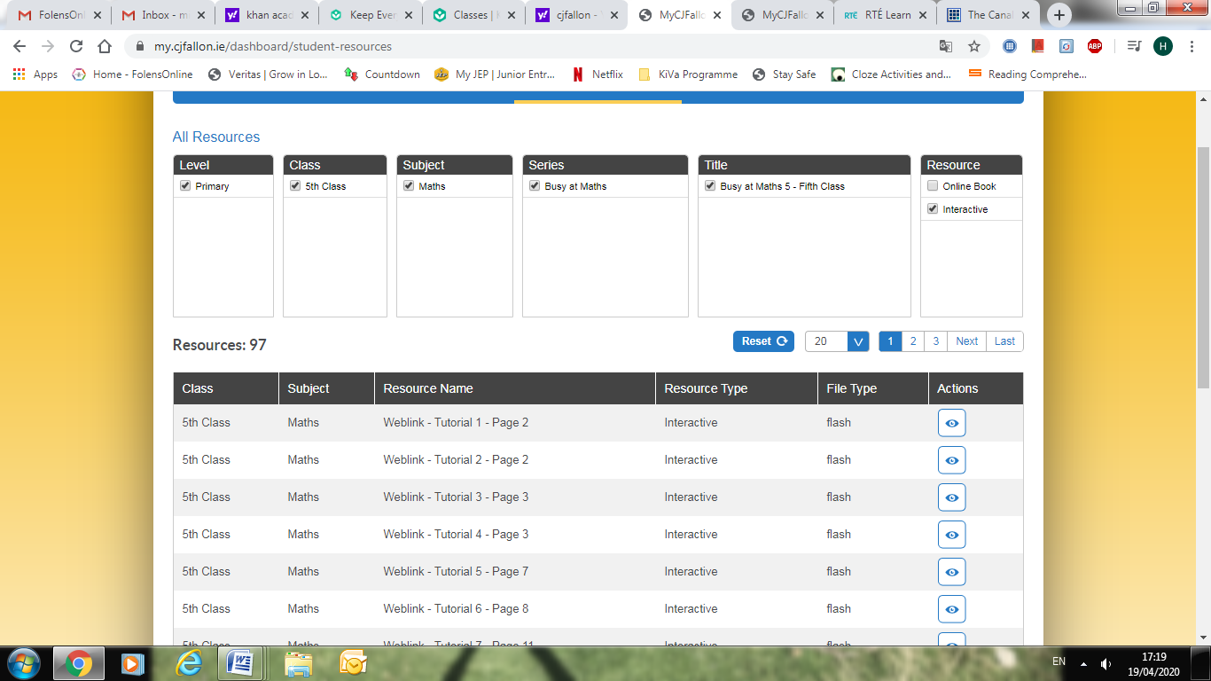

(Of course, you are free to explore all those resources for all the subjects we cover! I am just showing you how to find the resources you need for the lessons below)

1. Revision of Percentages

* View LiveBoard Maths Video “Revision of Fractions and Decimals” (attached to blog post)
* Go to www.khanacademy.org

Click on login (You can find your login and password at the bottom of this document)

Once you have successfully logged in, you should see “Miss Mulholland’s 5th Class” followed by 2 assignments...

“Converting percentages to decimals & fractions example” is a very helpful video to watch.

“Converting between percents, fractions, & decimals” is an activity to follow.

* Have a look at Busy at Maths Pg. 120

Here, we are revising changing fractions into decimals or decimals into fractions.

***When changing fractions into decimals we can divide the top number by the bottom number (we must be careful of the placement of our decimal point) or else we can use our arches to change the denominator into something over 100 (what we do on the bottom we must do on the top).***

Try Q 1, Q 2 and Q 3

2. Percentages Problems

* View Liveboard Maths Video “Finding the Percentage of a Number” (attached to blog post)

***How do I find a percentage of a number? How do I find a decimal fraction of a number? Change it into a fraction! Then we need to divide by the bottom and multiply by the top.***

* Have a look at Busy at Maths Pg. 122

Try Q 2

3. Finding the Full Amount

* View Liveboard Maths Video “Finding the Full Amount when Given a Percent” (attached to blog post)
* On the CjFallon app (above) find and play Weblink Tutorial 72
* Have a look at Busy at Maths Pg. 123

Try Q 2, Q 3, Q 8 and Q 9

4. Increasing and Decreasing

* On the CjFallon app (above) watch Weblinks 73 and 74

***How do we find a fraction of a number? We divide by the bottom and multiply by the top!***

***How do we find a percentage of a number? We change the percentage into a fraction, and do the same as above – divide by the bottom and multiply by the top!***

* Have a look at Busy at Maths Pg. 124

Try Q 2, Q 4, Q 6 and Q 7

Khan Academy Logins

Please respect your classmates and only use your own login details.

