English | Maths | Gaeilge | Religion | Other subjects
Letter Sounds and Writing:  New sound: j (see video on blog)  Phonics booklet (Stapled pages in work folder) do following pages:  - 10th page: letter j  - 11th page: ‘CVC words’  Big handwriting book: page 54 and 55  Small handwriting book: j page  Copy/spell little words in copy: jig, jog, jam, jet, jug, job | Maths song on YouTube:  The Ants go Marching  https://www.youtube.com/watch?v=Pjw2A3QU8Qg  Days of the Week  https://www.youtube.com/watch?v=mXMofxtDPUQ | This week's lesson: 24: Cinnín Óir agus na Trí Bhéar (Goldilocks and the Three Bears)  1. Cluiche Kim: See video for this game on blog titled ‘Cluiche Kim’  2. Complete page 85 in Abair Liom workbooks (Video instructions on blog)  3. Watch Cinnín Óir agus na Trí Bhéar on Abair Liom website https://content.folensonline.ie/programmes/AbairLiom/JI/resources/Stories/AL_JI_ACT_Sceal_L24_CinninOir/build/index.html  4. Comhrá (conversation):  An bhfuil ocras ort? (are you hungry?)  Tá ocras orm (I am hungry)  Níl ocras orm (I am not hungry)  (See video on blog)  **Don’t worry if the children are finding Gaeilge challenging. Listening to the language and playing games exposes them to the language and you will be surprised what they learn from doing this!** | May is the Month of Mary.  The children can repeat ‘Hail Mary’ after an adult  each day during this month.  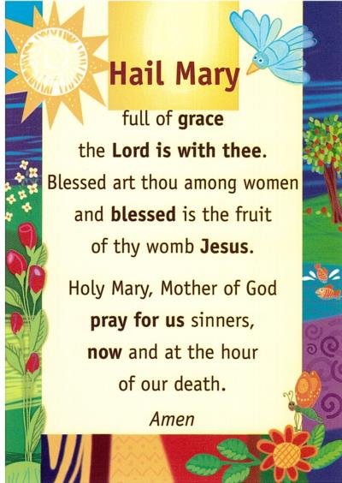  Activities:  Grow in Love: We are on Theme 8: Water  Lesson 1: Water is Wonderful  - ‘Mesi Goes for Water Story’ video on the blog  - Prayer: Hail Mary  - Visit growinlove.ie  Email/username: trial@growinlove.ie  Password: growinlove  Watch: Enestina  Song: Water  Activity: Caring for Water  - Workbook pages: complete pages 46 and 47 | All About Bees:  1.Story: The Very Greedy Bee https://www.youtube.com/watch?v=yw77rwV1LV0  2.How do bees make honey?  https://www.youtube.com/watch?v=uES_6CIgle0  3.After watching the video, discuss the process together. Retell how honey is made in your own words. Can you remember the names of the different bees? Can you draw the different bees doing their special jobs? Can you spot any bees working in your garden?  4.Bee art – see pictures on blog for inspiration  Song:  ‘ I Know an Old Lady’ https://www.youtube.com/watch?v=oNwmzDlyCt8  PE:  -Your favourite outdoor exercise  - Daily run  - ‘Enzo the Bee’ Yoga https://www.youtube.com/watch?v=uyj5LooYWyg
Online Games: New activities for this week!
Khan Academy Kids app (free to download) I have set up an account on this app.
Please email misstansey2020@gmail.com to get the access code for your child. The children can sign in and complete activities I have set for them (no pressure to join in on this if you are trying to avoid screen time )
Sight words:  New words: I, like  Sight word activities: Choose from activities on sight word note  Sight word reader: What I Like (uploaded to blog)  Watch: ‘Yoga’ guided reading video.  Share a bedtime story every night | Active maths/puzzles:  - Jigsaws  - Colour by number sheet (on blog)  - Every day complete sentences:  Yesterday was _______  Today is ________  Tomorrow will be ______  The month is _______  The season is ________  And discuss the daily weather
Oral Language:  Rainbow Oral Language Programme online: Unit 11: Up in the Treehouse  https://rainbow.cjfallon.ie/#/units/junior/11 | Busy at Maths books:  Small book: page 31, 32, 33, 34  Big book: page 106, 107

