English | Maths | Gaeilge | Religion | Other subjects
Letter Sound:  New sound: z (watch video on blog)  Writing (One activity each day)  - Find the letter z worksheet (on blog)  - Big handwriting book: p. 62 and 63  - Small handwriting book: z page  - Copy/spell little words in copy: zip, zap, zag, zig, zit, zen  - Worksheet: Z blending and spelling (on blog)  Extra challenge: Write a simple sentence using a z word and some known sight words example: Her zip is red.  Sight words:  New words: her, and  Revision words: this, is, a, he, the, to  Sight word activities: Choose from activities on sight word note to introduce new words and to revise previous words  Reading:  Sight word reader: Maria and her Teacher (uploaded to blog)  Rainbow Reader: ‘Yoga’ story in ‘Fun at Home’ book  Share a bedtime story every night  Extra reading:  If you would like access to additional readers online, please get in touch misstansey2020@gmail.com | Maths song/story on YouTube:  Night Monkey, Day Monkey  https://www.youtube.com/watch?v=ICxLOO9pua0  The Ants go Marching  https://www.youtube.com/watch?v=Pjw2A3QU8Qg  Days of the Week  https://www.youtube.com/watch?v=mXMofxtDPUQ | This week's lesson: 25. Súil Siar 4 (Revision week)  1.Tráth na gCeist – Súil siar 4  (Quiz: To access visit Abair Liom Online, lesson 25)  2. Complete page 86 and 87 in workbooks. (Video instructions on blog)  3. Poem: ‘An Siopa Milseán’ lesson 21 Abair Liom online -> Póstaer -> Dán  4. Song: Is Maith Liom on Teilifís (I like the television)  To access go to: Abair Liom online -> lesson 22 -> Póstaer -> Amhrán | May is the Month of Mary.  The children can repeat ‘Hail Mary’ after an adult  each day during this month.  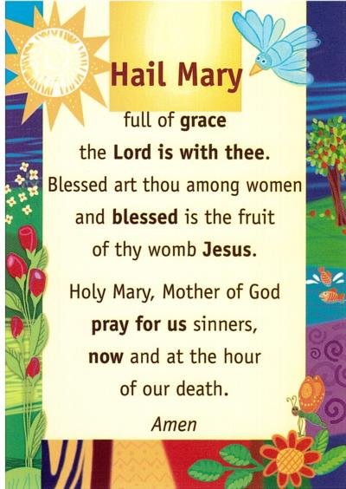  Activities:  Grow in Love: We are on Theme 8: Water  Lesson 2: Welcomed with Water  - Watch video story on blog: Welcomed  with Water  - Prayer: Hail Mary  - Visit growinlove.ie  Email/username: trial@growinlove.ie  Password: growinlove  Watch videos: Baptism and Holy Water  - Workbook pages: complete pages 48  and 49  - May Altar: Make a May Altar in  your garden or visit your May Altar and  say a prayer to Mary. | Let’s Make a video together!  See ‘I Know an Old Lady Rhyming Challenge’ video on the blog.  Entries can be sent to misstansey2020@gmail.com  Art:  Make a poster of your verse for the above challenge. Draw the old lady eating the animal your choice for your verse of the song!  PE:  - Outdoor games: skipping, hopscotch, football, races, hide and seek  - Daily run/walk  - Joe Wicks on YouTube  Science:  After watching  Night Monkey, Day Monkey  https://www.youtube.com/watch?v=ICxLOO9pua0  -Use chalk outside to trace shadows on the ground  - Mini-beast shadow challenge (on blog)
Khan Academy Kids:
It is great to see your progress and to hear that you are enjoying the app.
Extra activities added for this week!
Maths puzzles and language:
1. New colour by number sheet (on blog)
2. Every day continue to complete sentences:
Yesterday was _______
Today is ________
Tomorrow will be ______
The month is _______
The season is ________
And discuss the daily weather
3. Talk about activities we do during the day/night

Busy at Maths books:
Big book: page 108, 109, 110, 111, 112 (one page each day)
Oral Language:
Rainbow Oral Language Programme online: Unit 11: Up in the Treehouse
https://rainbow.cjfallon.ie/#/units/junior/11

