English | Maths | Gaeilge | Religion | Other subjects
Letter Sounds and Writing:  New sound: ai (New video on blog. There is quite a lot of content in the video. The video can be replayed or watched in parts over the four days)  Phonics booklet: pages 5- 8 (one page per day)  Page 5: b  Page 6: b  Page 7: Beginning letters  Page 8: ai | Maths song on YouTube:  Days of the Week song  https://www.youtube.com/watch?v=mXMofxtDPUQ | This week's lesson: 24: Cinnín Óir agus na Trí Bhéar (Goldilocks and the Three Bears)  1.Watch YouTube video story: Cinnín Óir agus na Trí Bhéar https://www.youtube.com/watch?v=91Aa8lBXUos (Video is also linked on blog)  2. Colour in: Goldilocks, Daddy bear, Mammy bear, Baby bear, a bowl, a chair and a bed. I will attach a colouring page to the blog that you can print. If you don’t have a printer, the children can draw the items from the list and colour them in. Keep them safe, we will be using them for a game next week!  3. Comhrá (Conversation): See video on blog.  Question: Cé thusa? (Who are you?)  Answer: Is mise ____ (I am _____ )  Revise this conversation this week.  4.Songs (Already covered in class. Songs uploaded to blog)  - Teidí Beag Álainn  - An bhfaca tú mo Shéamaisín? | May is the Month of Mary.  The children can repeat ‘Hail Mary’ after an adult each day during this month.  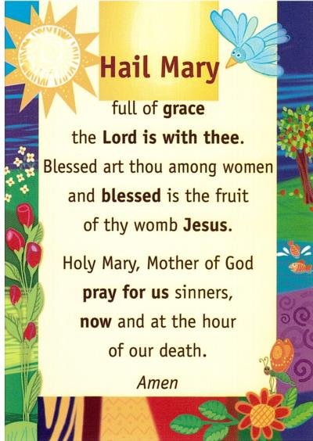  Activities:  Grow in Love: We are on Theme 10: Seasonal Lessons Lesson 5: Mary  - Prayer: Hail Mary  - Visit growinlove.ie: Junior Infants, Seasonal Lessons, Lesson 5.  Email/username: trial@growinlove.ie  Password: growinlove  Ave Maria Pictures: Discuss traditions during May, the Month of Mary (praying to Mary, praying the Hail Mary, making a May Altar, collecting flowers, remembering the stories we know about Mary)  - Workbook pages: complete pages 62 and 63 | Songs:  ‘ I Know an Old Lady’ https://www.youtube.com/watch?v=oNwmzDlyCt8  ‘Herman the Worm’  https://www.youtube.com/watch?v=0-rg7EIt1x4  PE ideas:  - Go for a walk  - Daily run  - Cosmic Kids ‘BUGS’ yoga: https://www.youtube.com/watch?v=qIT-9Nnlvn0  Science:  Our theme for this month is ‘mini-beasts’ (insects)  This week you could…  - Go on a mini-beast hunt in the garden  - Design and make your own bug hotel from junk art, outdoor materials or LEGO!  - Use a magnifying glass to study mini-beasts closely  - Make mini-beasts from PlayDough or junk art!  - Draw mini-beasts  I will put some pictures on the blog for inspiration!
Online Games: New activities for this week!
Khan Academy Kids app (free to download) I have set up an account on this app.
Please email misstansey2020@gmail.com to get the access code for your child. The children can sign in and complete activities I have set for them (no pressure to join in on this if you are trying to avoid screen time )
Sight words:  Revise same words from last week: this, is, a  Sight word activities: Choose from activities on sight word note  Sight word reader: Forest (uploaded to blog)  Rainbow reader: Fun at Home  Read: The New Baby page 7 - 11  Watch: ‘The New Baby’ video on blog for guided reading  Share a bedtime story | Active maths/puzzles:  - Jigsaws  - Adding with zero colour by number (on blog)  - Dot to dot (on blog)
Oral Language:  Rainbow Oral Language Programme online: Unit 11: Up in the Treehouse  https://rainbow.cjfallon.ie/#/units/junior/11 | Busy at Maths books:  Big book: page 102, 103, 104 and 105 (one page each day)

