WORK ACTIVITIES FOR THE WEEK – SAN DIEGO ZOO
DAY | ACTIVITIES - English / Geography / Science / Art
Tuesday 2nd June | Listening / Comprehension / Written answers  ACTIVITY 1  Click www.kids.sandiegozoo.org  - Click animals  - Click TIGERS  - Click TALE OF THE TIGER and LISTEN CAREFULLY TO THE VIDEO  - Answer the questions on the sheet provided  COMPLETE ACTVITIES 2, 3, 4  - EXTRA WORK– COLOURING SHEET on TIGERS. Click on Activities at top of Home page and scroll down to “TIGER FAMILY” –  - DOWNLOAD, PRINT, COLOUR  SPELLINGS – 5 to complete
 | ACTIVITIES – Maths / Geography / Science
Wednesday 3rd June | ACTIVITY 1 – Read over the TICKET PRICES SHEETS and answer the questions to the best of your ability  ACTIVITY 2 – Go back to Home Page for kids www.kids.sandiegozoo.org  - Click ACTIVITIES  - Scroll down to “ ALL TASTE, NO WASTE”  - PLEASE, PLEASE, PLEASE use the help of an adult for this yummy experiment! Read through the information then follow the instructions to make Bread and Butter Pudding!!  - I would LOVE to hear back what it tastes like! Pictures to my gmail please!  - Mr Loughran’s Tip: when it’s ready to eat, put a wee dollop of ice cream with it!!!! I’m so hungry writing this!!!!!  SPELLINGS – 5 to complete
 | ACTIVITIES – Maths / Geography / Science / Art
Thursday 4th June | ACTIVITY 1 – Click on to the home page again www.kids.sandiegozoo.org  - Click animals at top of page  - Scroll down and find ANACONDA ( the BIG snake )  - Read through the information about the Anaconda – it’s crazy how big these dudes can grow!!!  - Answer the quiz questions on the sheet provided to the best of your ability  - Go back to home page again www.kids.sandiegozoo.org  - Click ACTIVITIES, scroll down to LEAFY ART  - Click on the video to watch the instructions; paper, glue, leaves is all you need  - Make lots of them, take pictures and send them to my gmail  As it’s the last day of the tour, browse around the website learning all about the animals, play the games, do as many activities as you want!!!  SPELLINGS – assessment on the 10 words this week.

Tuesday 2nd June 2020
ACTIVITY 1: COMPREHENSION QUESTIONS ON TIGERS
Tip – listen to the video a few times then pause it when you hear the answers to the question you are on!!
What type of tigers live in the zoo?

What are the tiger’s names?

Name three types of habitat ( living area ) the tigers have in the zoo.

How can a tiger’s stripes be helpful? 2 reasons please

How much food can a tiger eat in one day?

What makes a tiger’s eyes so special?

What is the tiger’s special way of talking?

Tuesday 2nd June 2020

ACTIVITY 2 – LISTEN AND LEARN
Click on the icon “ stories,” scroll down and find the short story “ TIGER TIGER” – Simply listen to it and learn how the cubs bond.
ACTIVITY 3 – INTERACTIVE GAME “ THE TIGER TRAIL”
Click on the icon “games,” scroll down to “ TIGER TRAIL” and follow the instructions. There are 3 levels so choose and play at your leisure!
ACTIVITY 4 – FACTFILE and ART
Using the sheet provided, draw a Sumatran Tiger and write 8 SHORT facts about it! Any pictures uploaded and sent to me will win a prize!
Good Luck!

The Sumatran Tiger

THE SUMATRAN TIGER

FACTFILE
1.
2.
3.
4.
5.
6.
7.
8.

Wednesday 3rd June
MATHS
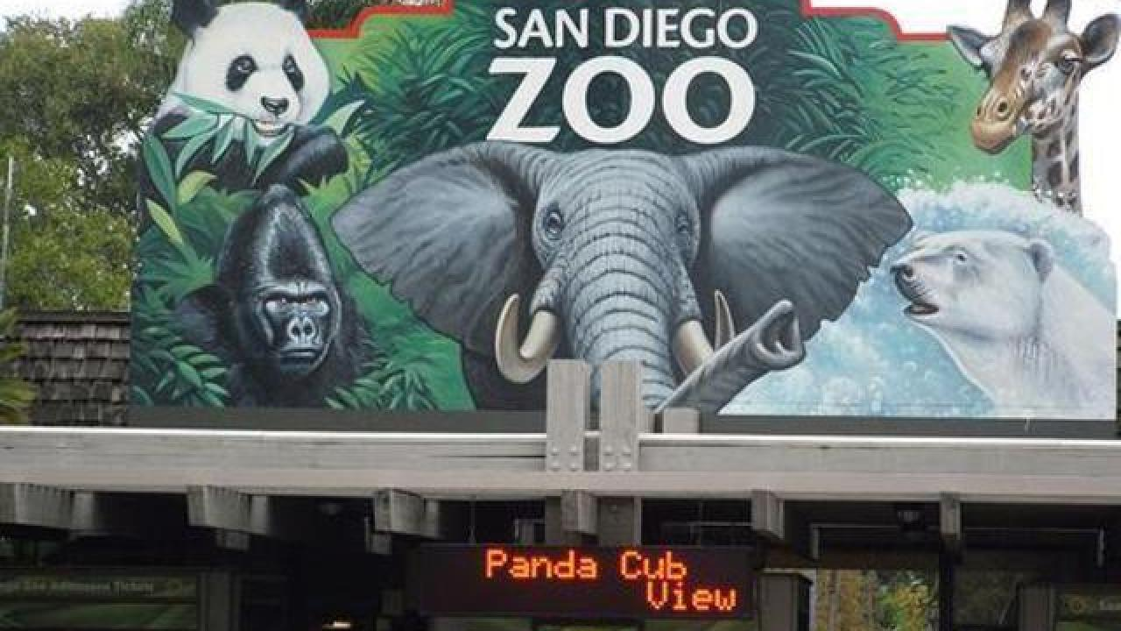

1-DAY PASS for san diego zoo
ADULT: AGES 12+ = $58 CHILD: AGES 3–11 $48
Answer the following questions
a/ | How much would it cost for your family to go to san diego zoo for 1 day?  answer: dollars
b/ | how much would it cost for three 14 year olds and two 9 year olds to go to the zoo?  Answer: dollars
c/ | what is the equivalent ( same as ) cost of 1 adult and 1 child in euros? ( get help with this from google and an adult )  Answer: euro
d/ | why do you think zoos can be expensive places to visit?  answer:
e/ | give 2 reasons why you would like / not like to work in a zoo.  1.  2.

wednesday 3rd june 2020
TICKETSfor san diego zoo

MULTI-DAY/MULTI-PARK PASSES

2-VISIT PASS
ADULT AGES 12+ = $92.80
CHILD AGES 3–11 = $82.80

SAN DIEGO 3-visit PASS

ADULT AGES 10+ = $154
CHILD AGES 3–9 = $144
- How much would it cost for 2 adults and 2 children to buy a 2 Visit Pass?

- How much would it cost for 3 adults to buy a 3 visit pass? Can anyone multiply instead of addition??? Go on, have a go!!!!

- How much do you think it costs to take a 2 year old to the zoo? TRY and give a reason for your answer!!!

Thursday 4th June 2020
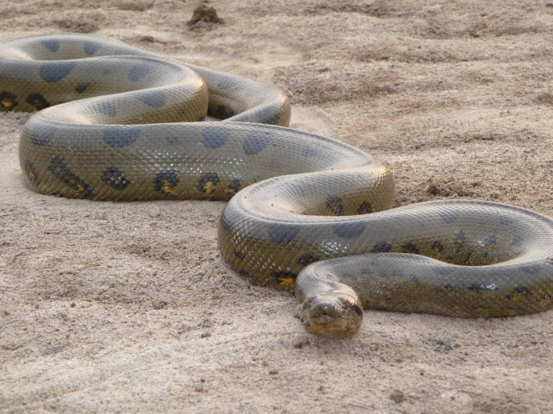
- What part of the world are Anacondas found in ?

- How long can they grow up to? Measure it out and you’ll see …

- How does the Anaconda kill its prey?

- Why are Anacondas hunted?

- The green Anaconda is the ……………………………………… ( longest / heaviest ) of all snakes.

- How big are baby Anacondas?

- What do you call a group of Anacondas?

SAN DIEGO ZOO SPELLINGS
Tuesday 2nd June
Cheetah

Crocodile

Anaconda

Elephant

Tiger

Wednesday 3rd June

Lizard

Flamingo

Penguin

