WORK FOR 8TH – 12TH JUNE 2020
It will be MATHS and READING primarily for the next few weeks so focus and work your way through each page, each day! Some nice little online games too so do them after written work ! Good luck!
DAY | ACTIVITIES – Busy at Maths | TABLES
Monday  READ EVERY DAY! | PATTERN ALL AROUND US – pages 147 + 148 ( written work )  Online Work- go to www.cjfallon.ie / Log in / 3rd Class / Maths / Busy at maths / Under “RESOURCES” click “ Interactive”  Find Weblink 92 page 147 then click the little eye | × 8 ÷ 8  Practice each day / choose 4 each day to learn  Eg, 1 × 8 = 8 / 8 ÷ 8 = 1  2 × 8 = 16 / 16 ÷ 8 = 2  3 × 8 = 24 / 24 ÷ 8 = 3  4 × 8 = 32 / 32 ÷ 8 = 4
Tuesday  READ EVERY DAY! | PATTERN ALL AROUND US – page 149 ( written work ) | × 8 ÷ 8  Practice each day / choose 4 each day to learn  5 × 8 = 40 / 40 ÷ 8 = 5  6 × 8 = 48 / 48 ÷ 8 = 6  7 × 8 = 56 / 56 ÷ 8 = 7  8 × 8 = 64 / 64 ÷ 8 = 8
Wednesday  READ EVERY DAY! | PATTERN ALL AROUND US – page 150 ( written work ) ( written work ) ( written work )  Online Work- go to www.cjfallon.ie / Log in / 3rd Class / Maths / Busy at maths / Under “RESOURCES” click “ Interactive”  Find Weblink 93 page 150 then click the little eye | × 8 ÷ 8  Practice each day / choose 4 each day to learn  9 × 8 = 72 / 72 ÷ 8 = 9  10 × 8 = 80 / 80 ÷ 8 = 10  11 × 8 = 88 / 88 ÷ 8 = 11  12 × 8 = 96 / 96 ÷ 8 = 12
Thursday  READ EVERY DAY! | PATTERN ALL AROUND US – page 151 ( written work )  Online Work- go to www.cjfallon.ie / Log in / 3rd Class / Maths / Busy at maths / Under “RESOURCES” click “ Interactive”  Find Weblink 94 page 151 then click the little eye | × 8 ÷ 8  Practice each day / choose 4 each day to learn  Google “ Hit the Button Top Marks”  Choose “Times Tables / Division Facts”  Play as many games as you can on × 8 ÷ 8
Friday  READ EVERY DAY! | SCIENCE / MATHS / COOKING  Finn’s Mug Cake!!  Send pictures through Seesaw or Gmail please of you preparing and eating!  Might make one myself | ASSESSMENT –  Write out × 8 ÷ 8  Mark yourself, take a picture and send through Seesaw or Gmail!  Hit The Button !!!

Finn’s Mug Cake!
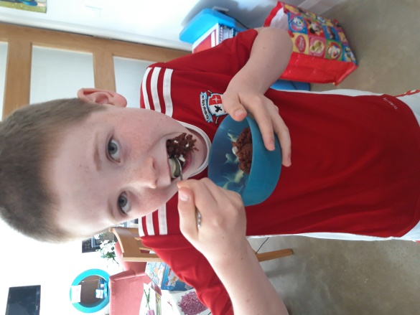
So the INGREDIENTS are: And the RECIPE is.
4 tblsp self-raising flour, STEP 1, put 4 tbsp of self-raising flour,
4 tblsp caster sugar, 4 tbsp caster sugar, 2 tbsp cocoa powder,
2 tblsp cocoa powder Into the largest mug you can find (I used a pyrex jug which was big enough)
1 medium egg, And mix.
3 tblsp milk,
3 tblsp sunflower oil, step 2,Add 1 medium egg,and mix as much
a few drops of vanilla, as you can.
2 tblsp of white chocolate chips.
step 3,Add 3 tbsp of milk,3 tbsp sunflower oil
and a few drops of vanilla then mix till it is
smooth then add 2 tbsp of white and mix
again.

step 4,Put the mug into the center of the
microwave and cook on high 1.5 - 2 mins or
till it stops rising.

