3rd Class – Week of 25th May 2020
Literacy
Monday 18th | Word Sorts  Yellow 33  Blue sort 3 -  Word Sorts – cut out, sort out, read out + 4 sentences  Comprehension / Grammar + Punctuation Work “ Get Set” pages 236 - 241  “Famous Irish Lanscapes”- TRY and complete the work by Friday .  If you get the opportunity read this information with your child. Take a page each and read it as a shared reading experience.  ACTVITIES – PAGE 240  A – “Talk About” B – What have you learned questions?
Tuesday 19th | Spellings:  sort out, read out + 4 sentences  Comprehension / Grammar + Punctuation Work “ Get Set” pages 236 - 241  “Famous Irish Lanscapes”- TRY and complete the work by Friday .  If you get the opportunity read this information with your child. Take a page each and read it as a shared reading experience.  ACTIVITIES – PAGE 240  C – fill in blanks D – true or false
Wednesday 20th | Spellings:  sort out, read out + 4 sentences  Comprehension / Grammar + Punctuation Work “ Get Set” pages 236 - 241  “Famous Irish Lanscapes”- TRY and complete the work by Friday .  If you get the opportunity read this information with your child. Take a page each and read it as a shared reading experience.  ACTIVITIES – PAGE 241  E – write the questions F – mixed up sentences
Thursday 21th | Spellings:  Assessment on 12 words  Comprehension / Grammar + Punctuation Work “ Get Set” pages 236 - 241  “Famous Irish Lanscapes”- TRY and complete the work by Friday .  If you get the opportunity read this information with your child. Take a page each and read it as a shared reading experience.  ACTIVITIES  G – draw a picture
Mr Loughran’s Good / Bad Joke of The Week – please share your jokes with me please!
Q. How do you make a sausage roll?
A. Push it down a hill!

Maths: DIVISION 3 OR AREA ( depending on what you did last week ) – work through a little bit each day on each topic!
Topic Work: AREA pages 161 – 164 Busy at Maths
INTERACTIVE LESSONS ON cjfallon : tutorials 100, 101, 102
OR
DIVISION 3
Pages 137-142 + A Quick Look Back page 143
INTERACTIVE LESSONS ON cjfallon : tutorials 86 - 89

Maths Interactive Tutorials ( CJfallon.ie )
- Click 3rd Class
- Click Maths
- Click Busy at Maths
- Click Interactive
- Go to Tutorials for short teaching lessons
Number work: Tables ×4 / ÷4 : “ HIT THE BUTTON” ICT GAME ( just google it and let rip! )
Gaeilge
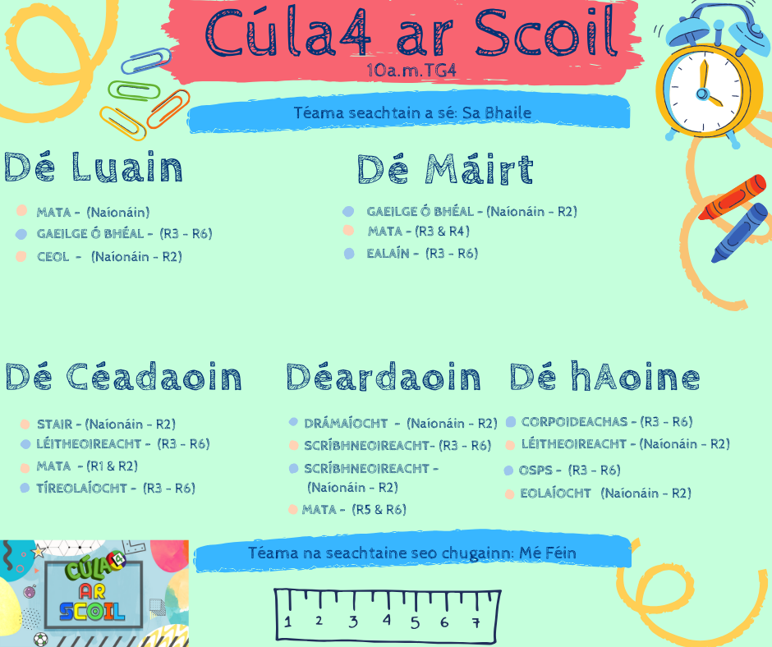
PLEASE TUNE IN TO TG4 FOR THIS WEEK’S LESSONS! THEY’RE GREAT!
CÓMHRA - conversation

Gaeilge: CONTINUATION OF MÉ FÉIN – Myself 10 – 20 minutes each day!

An Aimsir – the weather! ABAIR LIOM PAGES 122-
This week I’ll be adding a few things about what would have been the topic this month; the children can say a few things about the weather as part of their ongoing build up of Cómhra ie conversation in irish
“Inis dom fút féin” – “tell me about yourself” : the children should be able to chat for approximately 1 minute covering the following questions: get them to do this every day this week as if you’re interviewing them for a job!!!

- Cad is ainm duit?

- Cén aois thú?

- Cá bhfuil tú i do chónaí?

- Cé mhéad duine atá i do theaghlach?

- An bhfuil aon deartháireacha agat?

- An bhfuil aon deirfiúracha agat?

- An bhfuil aon pheata agat? Cad is ainm dí / do?

- Cén dath atá ar do chuid gruaige?

- Cén dath atá ar do shúile?

- Cén rang ina bhfuil tú?

- Cén sort aimsire atá ann inniu? ( what sort of weather is it today? Lá . . . té / fuar / fliuch / gaofar atá ann inniu. ( It is warm / cold / wet / windy today )

Ag Léamh – Reading

Abair Liom Page
Ag Scriobh – Writing ( continued )
Keep a diary for each day describing the weather in your copy plus a picture – use the poster on pages 122 + 123 for vocabulary to describe weather
Example ;
An Luan ( Monday )
Cén sort aimsire atá ann inniu? Lá fliuch atá ann inniu. Té sé ag cur baistí.

Google Translate from Irish to English will be there to help the kids!
www.duolingo.com – brilliant website also for a browse!

Science / Geography: Topic – HEAT 2 week topic
Learning Objectives –
ƒƒ. Learn that heat can be transferred.
ƒ. Recognise that temperature is a
measurement of how hot something is.
ƒ. Measure changes in temperature using
a thermometer.
ƒ. Measure and compare temperature in
different places in the classroom, school
and environment and explore the
reasons for variations.
ƒ. Understand that the sun is Earth’s most
important heat source.
ƒ. Identify ways in which homes, buildings
and materials are heated.
SMALL WORLD Science / Geography Book pages 100 – 104

Lots of great experiments BUT …
PLEASE HAVE AN ADULT HELP YOU AND SEND ON PICTURES TO MY GMAIL PLEASE!

Week of 25th May: pages102 – 104
- Read, discuss, complete activities questions page 104. Obviously the “classroom” experiments can be done at home.
- Complete the work over the week and I’d LOVE to see some pictures of you carrying out the experiments!!!

Religion
- Read the Story of St. Kevin and colour the picture of him.
- This is the last week of May so anyone who still wants to create a May Altar and take a picture , please do so!

